VPC Creation

- Create ShaneVPC2 with CIDR 10.0.1.0/24
aws ec2 create-vpc --cidr-block 10.0.1.0/24 --tag-specifications ‘ResourceType=vpc,Tags=[{Key=Name,Value=ShaneVPC2’}] --region ap-south-1

- List all VPCs created
aws ec2 describe-vpcs

- Assign value of ShaneVPC2 id to a variable.
vpcid=$(aws ec2 describe-vpcs --filters ‘Name=tag:Name,Values=ShaneVPC2’ --query ‘Vpcs[].VpcId’ --output text)

- Update VPC attributes
- Use associate-vpc-cidr , create-tag for changing VPC CIDR and Name

VPC Subnet Creation
- PrivateSubnetA2 -10.0.1.128/27 -ap-south-1a
aws ec2 create-subnet --vpc-id $vpcid --cidr-block 10.0.1.128/27 --availability-zone ap-south-1a --tag-specifications ‘ResourceType=subnet,Tags[{Key=Name,Value=PrivateSubnetA2}]’

- PrivateSubnetB2 -10.0.1.64/26 -ap-south-1b
aws ec2 create-subnet --vpc-id $vpcid --cidr-block 10.0.1.64/26 --availability-zone ap-south-1b --tag-specifications ‘ResourceType=subnet,Tags=[{Key=Name,Value=PrivateSubnetB2}]’

- PrivateSubnetC2 -10.0.1.192/27 -ap-south-1c
aws ec2 create-subnet --vpc-id $vpcid --cidr-block 10.0.1.192/27 --availability-zone ap-south-1c --tag-specifications ‘ResourceType=subnet,Tags=[{Key=Name,Value=PrivateSubnetC2}]’

- PublicSubnetA2 -10.0.1.0/26 -ap-south-1a
aws ec2 create-subnet --vpc-id $vpcid --cidr-block 10.0.1.0/26 --availability-zone ap-south-1a --tag-specifications ‘ResourceType=subnet,Tags=[{Key=Name,Value=PublicSubnetA2}]’

- PublicSubnetB2 -10.0.1.160/27 -ap-south-1b
aws ec2 create-subnet --vpc-id $vpcid --cidr-block 10.0.1.160/27 --availability-zone ap-south-1b --tag-specifications 'ResourceType=subnet,Tags=[{Key=Name,Value=PublicSubnetB2}]'

- PublicSubnetC2 -10.0.1.224/27 -ap-south-1b
aws ec2 create-subnet --vpc-id $vpcid --cidr-block 10.0.1.224/27 --availability-zone ap-south-1c --tag-specifications 'ResourceType=subnet,Tags=[{Key=Name,Value=PublicSubnetC2}]'

- To Extract all Subnets of ShaneVPC2
aws ec2 describe-subnets --filters “Name:vpc-id,Values=$vpcid”

Internet Gateway
- Create IGW -ShaneVPC2igw
aws ec2 create internet-gateway --tag-specifications ‘ResourceType=internet-gateway,Tags=[{Key=Name,Value=ShaneVPC2igw}]’

- Assigning variable igwid (Internet Gateway Id)
igwid=$(aws ec2 describe-internet-gateways --filters 'Name=tag:Name,Values=ShaneVPC2igw' --query 'InternetGateways[].InternetGatewayId' --output text)

- Attach IGW
aws ec2 attach-internet-gateway --vpc-id $vpcid --internet-gateway-id $igwid

NAT Gateway
- Allocate Elastic IP address
aws ec2 allocate-address --domain vpc --tag-specifications ‘ResourceType=elastic-ip,Tags=[{Key=Name,Value=ShaneVPC2eip}]’

- Assigning variable eipallocid (Elastic Allocation ID)
eipallocid=$(aws ec2 describe-addresses --filters ‘Name=tag:Name,Values=ShaneVPC2eip’ --query ‘Addresses[].AllocationId’ --output text)

- Assigning variable pubsubaid (PublicSubnetA Id)
pubsubaid=$(aws ec2 describe-subnets --filters ‘Name=tag:Name,Values=PublicSubnetA2’ --query ‘Subnets[].SubnetId’ --output text)

- Create NAT Gateway with Public Subnet Id, Allocation of Elastic IP, Tag
aws ec2 create-nat-gateway --subnet-id $pubsubaid --allocation-id $eipallocid --tag-specifications ‘ResourceType=natgateway,Tags=[{Key=Name,Value=ShaneVPC2natgw}]’

Public Route Table

- Creating Public Route Table ( pubrtbvpc2 )
aws ec2 create-route-table --vpc-id $vpcid --tag-specifications ‘ResourceType=route-table,Tags=[{Key=Name,Value=pubrtbvpc2}]’

- Assigning variable pubrtbvpc2id ( pubrtbvpc2 Id)
pubrtbvpc2id=$(aws ec2 describe-route-tables --filters ‘Name=tag:Name,Values=pubrtbvpc2’ --query ‘RouteTables[].RouteTableId’ --output text)

- Create Route for Internet Access attaching IGW on 0.0.0.0/0 cidr block address
aws ec2 create-route --route-table-id $pubrtbvpc2id --destination-cidr-block 0.0.0.0/0 --gateway-id $igwid

- Assigning variables pubsubaid, pubsubbid, pubsubcid ( PublicSubnetA Id,PublicSubnetB Id, PublicSubnetC Id )
a) pubsubaid=pubsubcid=$(aws ec2 describe-subnets --filters 'Name=tag:Name,Values=PublicSubnetA2' --query 'Subnets[].SubnetId' --output text)
b) pubsubbid=pubsubcid=$(aws ec2 describe-subnets --filters 'Name=tag:Name,Values=PublicSubnetB2' --query 'Subnets[].SubnetId' --output text)
c) pubsubcid=pubsubcid=$(aws ec2 describe-subnets --filters 'Name=tag:Name,Values=PublicSubnetC2' --query 'Subnets[].SubnetId' --output text)

- Associating all three public subnets to Public Route Table
- PublicSubnetA2
aws ec2 associate-route-table --subnet-id $pubsubaid --route-table-id $pubrtbvpc2id
- PublicSubnetB2
aws ec2 associate-route-table --subnet-id $pubsubbid --route-table-id $pubrtbvpc2id
- PublicSubnetC2
aws ec2 associate-route-table --subnet-id $pubsubcid --route-table-id $pubrtbvpc2id

Private Route Table

- Creating Private Route Table ( privrtbvpc2 )
aws ec2 create-route-table --vpc-id $vpcid --tag-specifications ‘ResourceType=route-table,Tags=[{Key=Name,Value=prirtbvpc2}]’

- Assigning variable prirtbvpc2id ( prirtbvpc2 Id )
prirtbvpc2id=$(aws ec2 describe-route-tables --filters 'Name=tag:Name,Values=prirtbvpc2' --query 'RouteTables[].RouteTableId' --output text)

- Assigning variable natgwid (NAT Gateway ID)
natgwid=$(aws ec2 describe-nat-gateways --filter 'Name=tag:Name,Values=ShaneVPC2natgw' --query 'NatGateways[].NatGatewayId' --output text)

- Creating Route for NAT Gateway
aws ec2 create-route --route-table-id $prirtbvpc2id --destination-cidr-block 0.0.0.0/0 --nat-gateway-id $natgwid

- Assigning variables prisubaid, prisubbid, prisubcid ( PrivateSubnetA2 Id, PrivateSubnetB2 Id, PrivateSubnetC2 Id )
- prisubaid=$(aws ec2 describe-subnets --filters 'Name=tag:Name,Values=PrivateSubnetA2' --query 'Subnets[].SubnetId' --output text)
- prisubbid=$(aws ec2 describe-subnets --filters 'Name=tag:Name,Values=PrivateSubnetB2' --query 'Subnets[].SubnetId' --output text)
- prisubcid=$(aws ec2 describe-subnets --filters 'Name=tag:Name,Values=PrivateSubnetC2' --query 'Subnets[].SubnetId' --output text)

6) Associating all three private subnets to Private Route Table
- PrivateSubnetA2
aws ec2 associate-route-table --subnet-id $prisubaid --route-table-id $prirtbvpc2id
- PrivateSubnetB2
aws ec2 associate-route-table --subnet-id $prisubbid --route-table-id $prirtbvpc2id
- PrivateSubnetC2
aws ec2 associate-route-table --subnet-id $prisubcid --route-table-id $prirtbvpc2id

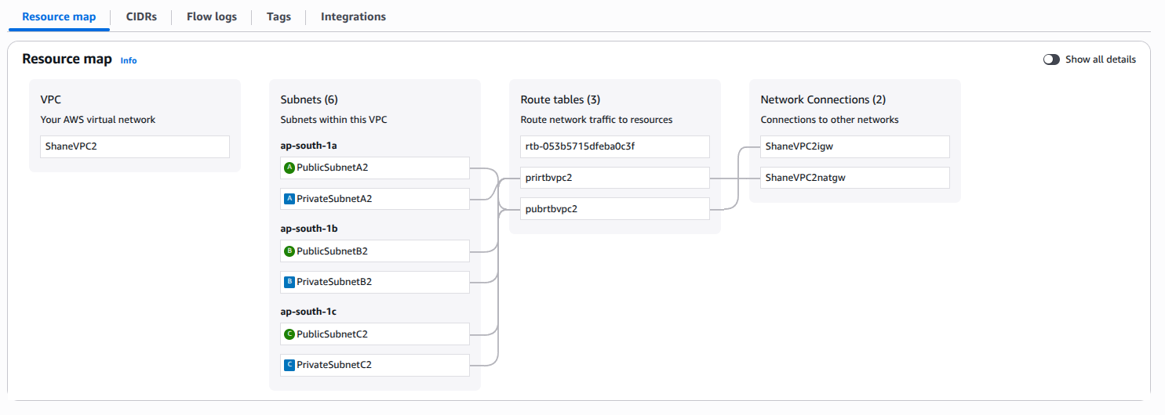

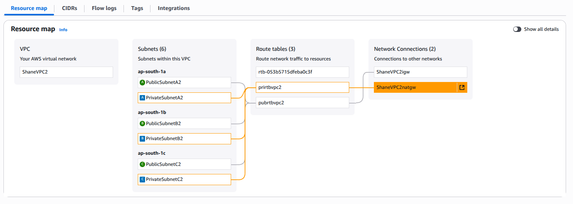

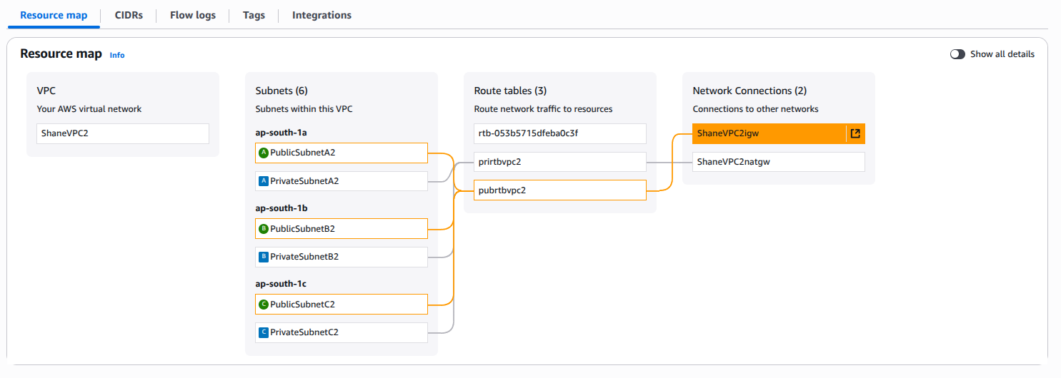

Security Groups
- ChatWebSG
- Create Security Group for ChatWeb
chat-web-sg-cli
aws ec2 create-security-group --group-name chat-web-sg-cli --vpc-id $vpcid --description “Security Group for Chat Web Tier for ShaneVPC2”

- Assigning variable chatwebsgcliid ( chat-web-sg-cli Id )
chatwebsgcliid=$(aws ec2 describe-security-groups --filters 'Name=group-name,Values=chat-web-sg-cli' --query 'SecurityGroups[].GroupId' --output text)

Doing It Later (Can Ignore)
- Authorize Inbound Rule for chat-web-sg-cli
-Port 80,443 Access 0.0.0.0/0
aws ec2 authorize-security-group-ingress --group-id $chatwebsgcliid --ip-permissions '[{"IpProtocol":"tcp","FromPort":80,"ToPort":80,"IpRanges":[{"CidrIp":"0.0.0.0/0","Description":"Port 80 Access"}], {"IpProtocol":"tcp","FromPort":443,"ToPort":443,"IpRanges":[{"CidrIp":"0.0.0.0/0","Description":"Port 443 Access."}]}, {"IpProtocol":"tcp","FromPort":22,"ToPort":22,"IpRanges":[{"CidrIp":"0.0.0.0/0","Description":"Port 22 Access from anywhere"}]}]'

- ChatAppSG
- Create Security Group for ChatApp
chat-app-sg-cli
aws ec2 create-security-group --vpc-id $vpcid --group-name chat-app-sg-cli --description "SG for App Tier"
- Assigning variable chatappsgcliid ( chat-app-sg-cli Id )
chatappsgcliid=$(aws ec2 describe-security-groups --filters 'Name=group-name,Values=chat-app-sg-cli' --query 'SecurityGroups[].GroupId' --output text)

- Authorize Inbound Rule for chat-app-sg-cli
-Port 8001
-Source Group - chat-web-sg-cli
Note: Variables are used inside “ “” ” which are nested and can cause issues while using environment variables $variable

aws ec2 authorize-security-group-ingress --group-id $chatappsgcliid --ip-permissions "[{\"IpProtocol\":\"tcp\",\"FromPort\":8001,\"ToPort\":8001,\"UserIdGroupPairs\":[{\"GroupId\":\"$chatwebsgcliid\"}]},{\"IpProtocol\":\"tcp\",\"FromPort\":22,\"ToPort\":22,\"IpRanges\":[{\"CidrIp\":\"0.0.0.0/0\",\"Description\":\"SSH Access for 0.0.0.0/0\"}]}]"

OR ( 2nd One is Better “ ‘ “$chatwebsgcliid” ‘ “)

aws ec2 authorize-security-group-ingress --group-id $chatappsgcliid --ip-permissions '[{"IpProtocol":"tcp","FromPort":8001,"ToPort":8001,"UserIdGroupPairs":[{"GroupId":"'"$chatwebsgcliid"'"}]},{"IpProtocol":"tcp","FromPort":22,"ToPort":22,"IpRanges":[{"CidrIp":"0.0.0.0/0","Description":"SSH Access 0.0.0.0/0"}]}]'

- ChatAppSG
- Create Security Group for ChatDB
chat-db-sg-cli
aws ec2 create-security-group --group-name chat-db-sg-cli --vpc-id $vpcid --description "Security Group for DB Tier"

- Assigning variable chatdbsgcliid ( chat-db-sg-cli Id )
chatdbsgcliid=$(aws ec2 describe-security-groups --filters 'Name=group-name,Values=chat-db-sg-cli' --query 'SecurityGroups[].GroupId' --output text)

- Authorize Inbound Rule for chat-db-sg-cli
-Port 3306
-Source Group - chat-app-sg-cli
Note: Variables are used inside “ “” ” which are nested and can cause issues while using environment variables $variable

“ ‘ “$chatwebsgcliid” ‘ “
Using this method

aws ec2 authorize-security-group-ingress --group-id $chatdbsgcliid --ip-permissions '[{"IpProtocol":"tcp","FromPort":3306,"ToPort":3306,"UserIdGroupPairs":[{"GroupId":"'"$chatappsgcliid"'"}]}]'
- BastionHostSG
- Create Security Group for Bastion Host
chat-bast-sg-cli
aws ec2 create-security-group --group-name chat-bast-sg-cli --vpc-id $vpcid --description "SG for Bastion Host"

- Assigning variable chatbastsgcliid ( chat-bast-sg-cli Id )
chatbastsgcliid=$(aws ec2 describe-security-groups --filters 'Name=group-name,Values=chat-bast-sg-cli' --query 'SecurityGroups[].GroupId' --output text)

- Authorize Inbound Rule for chat-bast-sg-cli
-SSH Port 22
aws ec2 authorize-security-group-ingress --group-id $chatbastsgcliid --ip-permissions '[{"IpProtocol":"tcp","FromPort":22,"ToPort":22,"IpRanges":[{"CidrIp":"0.0.0.0/0","Description":"SSH Access to BastionHost"}]'}]

- Attaching Bastion Host SG to ChatWeb, ChatApp, ChatDB Tiers inorder to ssh into them.
ChatWeb
aws ec2 authorize-security-group-ingress --group-id $chatwebsgcliid --ip-permissions '[{"IpProtocol":"tcp","FromPort":22,"ToPort":22,"UserIdGroupPairs":[{"GroupId":"'"$chatbastsgcliid"'"}]}]'

ChatApp
aws ec2 authorize-security-group-ingress --group-id $chatappsgcliid --ip-permissions '[{"IpProtocol":"tcp","FromPort":22,"ToPort":22,"UserIdGroupPairs":[{"GroupId":"'"$chatbastsgcliid"'"}]}]'

ChatDB
aws ec2 authorize-security-group-ingress --group-id $chatdbsgcliid --ip-permissions '[{"IpProtocol":"tcp","FromPort":22,"ToPort":22,"UserIdGroupPairs":[{"GroupId":"'"$chatbastsgcliid"'"}]}]'

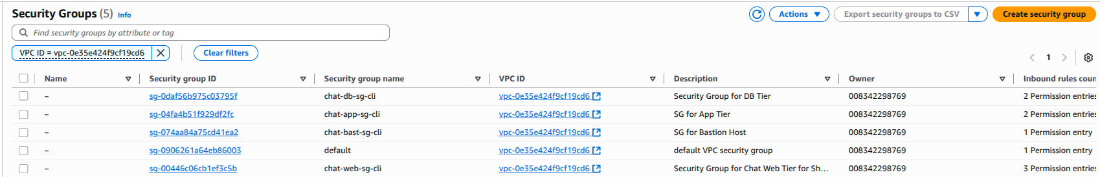

EC2 Instances
- ChatDBA2 Instance
AMI- Ubuntu 20.04
Instance Type - t3.micro
KeyPair - chatapp.pem
Security Group - chat-db-sg-cli
Subnet - prisubaid
Count - 1

aws ec2 run-instances --image-id $ec2amiid --instance-type "t3.micro" --key-name "chatapp" --subnet-id $prisubaid --security-group-ids $chatdbsgcliid --count 1 --tag-specifications 'ResourceType=instance,Tags=[{Key=Name,Value=ChatDBA2}]'

- ChatAppA2 Instance
AMI- Ubuntu 20.04
Instance Type - t3.micro
KeyPair - chatapp.pem
Security Group - chat-app-sg-cli
Subnet - pubsubaid
Count - 1

aws ec2 run-instances --image-id $ec2amiid --subnet-id $pubsubaid --instance-type "t3.micro" --count 1 --key-name "chatapp" --security-group-ids $chatappsgcliid --tag-specifications 'ResourceType=instance,Tags=[{Key=Name,Value=ChatAppA2}]'

- ChatWebA2 Instance
AMI- Ubuntu 20.04
Instance Type - t3.micro
KeyPair - chatapp.pem
Security Group - chat-web-sg-cli
Subnet - pubsubaid
Count - 1

aws ec2 run-instances --image-id $ec2amiid --subnet-id $pubsubaid --security-group-ids $chatwebsgcliid --key-name "chatapp" --instance-type "t3.micro" --count 1 --tag-specifications 'ResourceType=instance,Tags=[{Key=Name,Value=ChatWebA2}]'

- BastionHostA2 Instance
AMI- Ubuntu 20.04
Instance Type - t3.micro
KeyPair - chatapp.pem
Security Group - chat-web-sg-cli
Subnet - pubsubaid
Count - 1

aws ec2 run-instances --subnet-id $pubsubaid --security-group-ids $chatbastsgcliid --key-name "chatapp" --instance-type "t3.micro" --image-id "$ec2amiid" --count 1 --associate-public-ip-address --tag-specifications 'ResourceType=instance,Tags=[{Key=Name,Value=BastionHostA2}]'

ALB (Application Load Balancer)
- Internal ALB
- Security Group Setup
- alb-web-sg-cli (Public ALB)
Inbound: TCP 80 from 0.0.0.0/0
Outbound: TCP 80 to chatweb-sg
Create :-
aws ec2 create-security-group --group-name alb-web-sg-cli --vpc-id $vpcid --description "Security Group for Internet Facing ALB"
Id Variable:-
albwebsgcliid=$(aws ec2 describe-security-groups --filters ‘Name=group-name,Values=alb-web-sg-cli' --query 'SecurityGroups[].GroupId' --output text)
Authorize SG:-
aws ec2 authorize-security-group-ingress --group-id $albwebsgcliid --protocol tcp --port 80 --cidr 0.0.0.0/0

- chat-web-sg-cli (Web EC2 / Web ASG — Nginx)
Inbound: TCP 80 from alb-web-sg (source = SG ID)
Outbound: TCP 80 to alb-app-sg
Create :-
aws ec2 create-security-group --group-name chat-web-sg-cli --vpc-id $vpcid --description "Security Group for Web EC2 / Web ASG"
Id Variable :-
chatwebsgcliid=$(aws ec2 describe-security-groups --filters "Name=group-name,Values=chat-web-sg-cli" --query "SecurityGroups[].GroupId" --output text)
Authorize SG :-
# Inbound from alb-web-sg
aws ec2 authorize-security-group-ingress --group-id $chatwebsgcliid --ip-permissions "[{\"IpProtocol\":\"tcp\",\"FromPort\":80,\"ToPort\":80,\"UserIdGroupPairs\":[{\"GroupId\":\"$albwebsgcliid\"}]}]"
# Outbound to alb-app-sg
aws ec2 authorize-security-group-egress --group-id $chatwebsgcliid --ip-permissions "[{\"IpProtocol\":\"tcp\",\"FromPort\":80,\"ToPort\":80,\"UserIdGroupPairs\":[{\"GroupId\":\"$albappsgcliid\"}]}]"

- alb-app-sg-cli (Internal ALB)
Inbound: TCP 80 from chatweb-sg
Outbound: TCP 8001 to app-sg
Create :-
aws ec2 create-security-group --group-name alb-app-sg-cli --vpc-id $vpcid --description "Security Group for Internal ALB"
Id Variable :-
albappsgcliid=$(aws ec2 describe-security-groups --filters "Name=group-name,Values=alb-app-sg-cli" --query "SecurityGroups[].GroupId" --output text)
Authorize SG :-
# Inbound from chat-web-sg
aws ec2 authorize-security-group-ingress --group-id $albappsgcliid --ip-permissions "[{\"IpProtocol\":\"tcp\",\"FromPort\":80,\"ToPort\":80,\"UserIdGroupPairs\":[{\"GroupId\":\"$chatwebsgcliid\"}]}]"
# Outbound to app-sg
aws ec2 authorize-security-group-egress --group-id $albappsgcliid --ip-permissions "[{\"IpProtocol\":\"tcp\",\"FromPort\":8001,\"ToPort\":8001,\"UserIdGroupPairs\":[{\"GroupId\":\"$chatappsgcliid\"}]}]"
- chat-app-sg-cli (App EC2 / App ASG — Gunicorn)
Inbound: TCP 8001 from alb-app-sg
Outbound: TCP 3306 to db-sg (or general egress if using NAT)
Create :-
aws ec2 create-security-group --group-name chat-app-sg-cli --vpc-id $vpcid --description "Security Group for App EC2 / App ASG"
Id Variable :-
chatappsgcliid=$(aws ec2 describe-security-groups --filters "Name=group-name,Values=chat-app-sg-cli" --query "SecurityGroups[].GroupId" --output text)
Authorize SG :-
# Inbound from alb-app-sg
aws ec2 authorize-security-group-ingress --group-id $chatappsgcliid --ip-permissions "[{\"IpProtocol\":\"tcp\",\"FromPort\":8001,\"ToPort\":8001,\"UserIdGroupPairs\":[{\"GroupId\":\"$albappsgcliid\"}]}]"
# Outbound to db-sg
aws ec2 authorize-security-group-egress --group-id $chatappsgcliid --ip-permissions "[{\"IpProtocol\":\"tcp\",\"FromPort\":3306,\"ToPort\":3306,\"UserIdGroupPairs\":[{\"GroupId\":\"$dbsgcliid\"}]}]"
- db-sg (MySQL)
Inbound: TCP 3306 from app-sg only
Create :-
aws ec2 create-security-group --group-name db-sg-cli --vpc-id $vpcid --description "Security Group for MySQL DB"
Id Variable :-
dbsgcliid=$(aws ec2 describe-security-groups --filters "Name=group-name,Values=db-sg-cli" --query "SecurityGroups[].GroupId" --output text)
Authorize SG :-
# Inbound from app-sg
aws ec2 authorize-security-group-ingress --group-id $dbsgcliid --ip-permissions "[{\"IpProtocol\":\"tcp\",\"FromPort\":3306,\"ToPort\":3306,\"UserIdGroupPairs\":[{\"GroupId\":\"$chatappsgcliid\"}]}]"

